**2022 NAWLA Traders Market Exhibitor Marketing Kit**

Thank you for representing and advocating for NAWLA by being an exhibitor at the 2022 NAWLA Traders Market! Below, you’ll find some tools and best practices we’ve put together to make your participation in this event easy and worthwhile. These should help you promote the event to your network and to generate excitement!

In this kit you’ll find:

* A sample email to personally encourage friends and colleagues to attend
* An email signature to add to all your correspondence
* A website post example of language and an image to use
* Easy copy/paste social media posts

Please contact NAWLA Marketing Associate [Grace Darling](mailto:gdarling@nawla.org) if you have any questions or suggestions.

**Pass-Along Email**

Are your colleagues familiar with the NAWLA Traders Market? Use this email below to share your excitement about the 2022 event and your personal experience from past events. Copy and paste this into your email, add a personal touch and send!

Subject: **Join Us in Arizona for the 2022 NAWLA Traders Market**

Hi [NAME],

I am excited to share that [insert company name] will be exhibiting at the 2022 NAWLA Traders Market, held at the Phoenix Convention Center in Phoenix, Arizona, November 9-11. I invite you to join us at this can’t-miss industry event!

This annual event is a tradeshow focused exclusively on the forest products supply chain. Unlike other shows, the exhibitors are almost always manufacturers of lumber and lumber-related products, not machinery or other equipment providers. With eight hours of tradeshow floor time and more than three hours of dedicated networking time, Traders Market is the perfect opportunity to buy, sell and network while making lasting connections with your lumber industry peers.

Attendees will also have countless opportunities to network and gain industry insights. Mingle with fellow professional during our networking receptions, and learn about the most pressing industry topics, including the supply chain shortages, sales training, mergers and acquisition activity, and more during education and learning lounge sessions on the tradeshow floor.

[insert company name] will be in booth #[insert booth number]. Come by and chat with about [insert company features, products and talking points]!

These three days are always jam-packed with so much invaluable information, I look forward to this event each and every year. It’s the perfect combination of networking, education and tradeshow floor time, and you’ll leave this event with plenty of connections and industry knowledge to jump-start your business in 2022. Please reach out to me if I can provide additional details about the 2022 Traders Market. You can also learn more about this event on [their website](http://www.nawla.org/tradersmarket), and [register today](https://nawla.org/Events/Traders-Market/Registration).

Please keep in mind that this event is for NAWLA members only, so be sure to [contact NAWLA](mailto:info@nawla.org) for more information and to join today in order to attend.

I look forward to seeing you in Phoenix this November.

Sincerely,

[NAME SIGNATURE]

**Quick Demographic Facts**

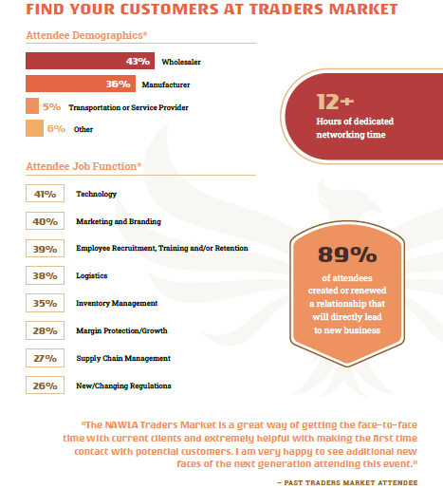

**Email Signature**

Share the 2022 NAWLA Traders Market event with all of your contacts by using the 2022 NAWLA Traders Market signature below your standard email signature. To use the email signature, follow these steps:

1. Copy the text and paste it into your email signature, following the instructions from your email provider. Here are instructions for [Outlook](https://support.office.com/en-us/article/Create-and-add-a-signature-to-messages-8ee5d4f4-68fd-464a-a1c1-0e1c80bb27f2), [Gmail](https://support.google.com/mail/answer/8395?co=GENIE.Platform%3DDesktop&hl=en) and [Yahoo Mail](https://help.yahoo.com/kb/SLN16030.html).
2. To insert the image, save it first by right clicking the below image and then select “Save as Picture.” Save it to your desktop and insert the image into your email signature.
3. To make the logo a clickable link to the website, right click on the image, click hyperlink and paste [https://www.nawla.org/page/2022-traders-market](https://www.nawla.org/page/2021-traders-market) into the URL box.

**[Your Standard Signature]**

Join me in Phoenix, Arizona, November 9-11, to network on and off the tradeshow floor, get a pulse on the industry through expert-led education sessions and explore the surrounding city at the 2022 NAWLA Traders Market.

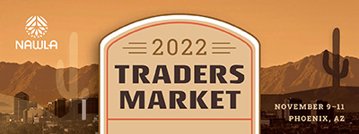

**Website Promotion**

Feel free to post the below language on your website or within an online blog/news. You can also save [this image](https://nawla.org/Portals/0/NAWLA_887842-22_TM_Graphics_facebook.jpg) to use with it.

**Meet lumber professionals from across North America at the 2022 NAWLA Traders Market**

The 2022 NAWLA Traders Market, taking place November 9-11 in Phoenix, Arizona, is *the* place to be this fall. Connect with industry professionals for this one-a-year lumber and building material tradeshows that is the only one focused almost exclusively on the lumber supply chain.

This event is the perfect opportunity for NAWLA members to network on and off the tradeshow floor, get a pulse on the industry through expert-led education sessions and explore the bustling downtown. [Learn more](https://www.nawla.org/tradersmarket) and [register today](https://nawla.org/Events/Traders-Market/Registration).

Not a NAWLA member? Please [contact NAWLA](mailto:info@nawla.org) for more information and to join today in order to attend this members-only event.

**Social Media Sharing Guide**

One of the best ways to promote the 2022 NAWLA Traders Market is through the social network of our members. Please consider posting about the seminar on your media platforms to share your excitement with peers.

The larger our presence on social media, the more users we can reach to spread the word about the 2022 NAWLA Traders Market.

This guide will provide you with easy ways to post about the event on social media. Below are sample posts you can copy and paste to any social accounts. Given the professional nature of the 2022 NAWLA Traders Market, we strongly encourage you to post on LinkedIn and tag NAWLA.

First, follow these helpful tips:

* When you post, you can [share this image](https://nawla.org/Portals/0/NAWLA_887842-22_TM_Graphics_facebook.jpg).
* Add this shortened link to all 2022 NAWLA Traders Market social media posts: <https://bit.ly/3kVE4aj>
* Share fun photos of past NAWLA events and tag attendees with whom you look forward to seeing again this year.
* Quick note: posts with images always grab more attention than posts without.
* Make it personal! Customize your message to make it relevant and personal where possible.

**Sample Posts**

* [Insert company name] is exhibiting at the 2022 NAWLA Traders Market. Join us in-person this fall to discover new ways to do business at this unique tradeshow event, taking place November 9-11 in Phoenix, Arizona.
* We’re excited to exhibit at the 2022 NAWLA Traders Market, November 9-11. Buy, sell and expand your networks by attending this once-a-year event this fall in Phoenix, Arizona. We hope to see you there!
* Looking for solutions to save you time and make more money? Look no further than the 2022 NAWLA Traders Market, November 9-11. Visit [insert company name] and explore the latest products and services for lumber industry professionals like yourself.
* Calling all lumber industry professionals: Discover solutions for strengthening and expanding your business at the 2022 NAWLA Traders Market. Time is running out to secure your spot for this annual event.